###### 

**PUCIT**

Punjab University College of Information Technology

Review Based Sentimental Analyzer

**First Deliverable**

**Version 1.0**

**TABLE OF CONTENTS**

1

Review Based Sentimental Analyzer 3

1 Introduction 3

1.1 Project/Product Feasibility Report 3

1.1.1 Technical Feasibility 3

1.1.2 Operational Feasibility 4

1.1.3 Economic Feasibility 4

1.1.4 Schedule Feasibility 4

1.1.5 Specification Feasibility 5

1.1.6 Information Feasibility 5

1.1.7 Motivational Feasibility 5

1.1.8 Legal & Ethical Feasibility 5

1.2 Project/Product Scope 5

1.3 Project/Product Costing 5

1.3.1 Project Cost Estimation By Function Point Analysis 6

1.4 CPM - Critical Path Method 8

1.5 Gantt chart 13

1.6 Introduction to Team members and their skill set 14

1.7 Tools and Technology with reasoning 15

1.8 Vision Document 15

1.9 Risk List 16

1 Introduction 16

1.1 Systems Specifications 17

1.2 Identifying External Entities 18

1.3 Context Level Data Flow Diagram 19

1.4 Capture "shall" Statements 19

1.6 Allocate Requirements 19

1.7 Prioritize Requirements 20

1.8 Requirements Trace-ability Matrix 20

1.9 High Level Use-Case Diagram 21

# Review Based Sentimental Analyzer

## 1 Introduction

The purpose of this document is to analyze and define the high-level features and needs of the REVIEW BASED SENTIMENTAL ANALYZER. It focuses on the needs of stakeholders and target users and it also focuses on how to fulfill their needs.

In this deliverable, we are concerned about planning and scheduling of the project. And it contains the following artifacts.

1. Project Feasibility
2. Project Scope
3. Project Costing
4. Critical Path Method Analysis (CPM Analysis)
5. Gantt Chart
6. Introduction to team members
7. Tools and Technologies
8. Vision Document
9. Risk List

## 1.1 Project/Product Feasibility Report

This document will help us to describe how the development of this website will be beneficial for domestic people. We have analyzed different types of feasibilities which are described below.

* Technical
* Operational
* Economic
* Schedule
* Specification
* Information
* Motivational
* Legal and Ethical

### 1.1.1 Technical Feasibility

* We are using **ReactJS** to make frontend of our web-based dashboards. React is a JavaScript library created by Facebook. It is an open-source JavaScript library which is used for building user interfaces specifically for single page applications.
* We will be using **Django framework of Python** with all its packages. Django is a Python based full stack web development framework means it is used to develop full-fledged websites in Python. It encourages rapid development. It delivers transparent and high-quality code writing, making it very feasible for developers. We will also create our APIs with Django framework which we have to use in our Mobile Application and ReactJS.
* We are using **React Native** to make our Mobile Application. React Native is an open-source mobile application framework created by Facebook. It is used to develop applications for Android, iOS, Web and UWP by enabling developers to use React along with native platform capabilities.
* We will use MS Visio for UML diagrams and MS Project for Gantt chart.
* We are using MS Office for documentation purposes.

### 1.1.2 Operational Feasibility

Our main target audience is Restaurant Owners and their customers, so we will make sure that REVIEW BASED SENTIMENTAL ANALYZER provides a user friendly graphical user interface to make it easy to use. Our users will operate the system very easily. User interface will be mobile responsive so that smartphone/tablet users could be able to operate the website smoothly.

### 1.1.3 Economic Feasibility

Economically this project is very feasible for both developers and users. Users are only required to have a pc, laptop or smartphone with internet facility. Economic feasibility of the project can be divided into two parts; cost estimates and benefit estimates discussed as follows.

**Cost Estimates:**

Cost estimates include development and operational costs. This will include the costs of designing, web and mobile app(Android & IOS) development and databases, costs of hardware support and internet connection. We are using function point method for calculating our effort in term of per month in this document.

**Benefit Estimates:**

We will deploy our system is different Restaurants, we will not charge one time cost from them instead we will charge a reasonable amount from them . Benefits of this project, for us, include monthly revenues generated from Restaurants.

### 1.1.4 Schedule Feasibility

Time is an important factor. Our project will require almost 6 months for completion. We will manage the whole process efficiently by dividing our project task into multiple modules and tasks so that we will meet the project requirements. Divided modules and tasks among team members and arrange multiple meetings to monitor the projects. So we are sure that the project will be completed in 6 months and then we will go for proper marketing campaign.

### 1.1.5 Specification Feasibility

Our requirements about our project are very clear and specific. Our main focus is to provide an online interaction between realistic customers and restaurant owners, to provide a graphical interface to restaurant owners to keep an eagle eye on reviews of customers. All the functional components are essential and not unrealistic at all.

### 1.1.6 Information Feasibility

The project is feasible since we have all the information required for the project and also, will provide reliable, complete and meaningful information to users so that they get complete understanding of everything. This system will have an ability to perform its intended functions and operations, fulfilling the requirement without experiencing any failure and system crash. We have researched solutions to solve the problem. The gathered information is sufficient.

### 1.1.7 Motivational Feasibility

Our primary concern is to provide a user friendly and very easy to use website and mobile app. We are sure that this website and mobile app will be quick to learn and user will not feel any difficulty using this.

### 1.1.8 Legal & Ethical Feasibility

Our project is legally and ethically feasible by all means, this is our idea and we are implemented it from scratch. We are not getting/stealing already written code from resource. The tools we’ll use are open source is also a legally good edge.

## 1.2 Project/Product Scope

It’s a project that will have both mobile and web application. Using mobile application the customer can give probe reviews about the services. The owner can monitor all the reviews provided by the customers using web application. The owner can also start a campaign to attract those customers who provided bad reviews and generate a report of reviews on weekly, daily and monthly basis. Actually this platform will help the owners to identify the problem in less sale of services and products and make decisions to solve those.

## 1.3 Project/Product Costing

Function points are derived using an empirical relationship based on countable (direct) measures of software’s information domain and assessments of software complexity.

Function Point Analysis can provide a mechanism to track and monitor scope creep. Function Point counts at the end of requirements; analysis, design, code, testing and implementation can be compared.

Information domain values are defined in the following manner:

### 1.3.1 Project Cost Estimation By Function Point Analysis

Function-oriented software metrics use a measure of the functionality delivered by the application as a normalization value. Since ‘functionality’ cannot be measured directly, it must be derived indirectly using other direct measures. Function-oriented metrics were first proposed by Albrecht, who suggested a measure called the function point. Function points are derived using an empirical relationship based on countable (direct) measures of software’s information domain and assessments of software complexity.

Function Point Analysis can provide a mechanism to track and monitor scope creep. Function Point counts at the end of requirements; analysis, design, code, testing and implementation can be compared. The function point count at the end of requirements and/or designs can be compared to function points actually delivered. If the project has grown, there has been scope creep. The amount of growth is an indication of how well requirements were gathered by and/or communicated to the project team. If the amount of growth of projects declines over time, it is a natural assumption that communication with the user has improved.

Function points are computed by completing the table shown in the figure below. Five information domain characteristics are determined and counts are provided in the appropriate table location.

Information domain values are defined in the following manner:

**Number of user inputs:**

**Customer:**

Customer Feedback (**High**)

**Owner:**

Login (**High**), manage profile (**Average**), start campaign (**High**), logout (**Low**).

**Administrator:**

Login (**High**), manage accounts (**Average**), delete accounts (**High**), update services (**Average**), logout (**Low**).

**Number of user outputs:**

Login Screen (**High**),, Feedback Screen (**High**),, Statistics Screen (**High**),, Manage Profiles Screen (**Average**),, Manage accounts screen (**Average**), Report Screen (**High**),, Campaign Screen (**High**),, Logout Screen (**Low**)., Restaurants Screen (**Low**)..

**Number of user inquiries:**

User will give Login credentials and system will give response. (**High**), Customer gives feedback from interface and system responds (**High**), Manage account (**Average**), Generate customized reports (**High**), Logout (**Low**), Admin can view details for any restaurant (**Average**).

**umber of files:** System data file (**High**).

**Number of external interfaces:**

Email alert notifications (**Average**), Message alert notifications (**Average**).

|  |  |  |  |  |  |  |  |  |
| --- | --- | --- | --- | --- | --- | --- | --- | --- |
| Measurement Parameter | Count | Weighting Factor   |  |  |  | | --- | --- | --- | | Low | Average | High | | | | Total |
| Number of user inputs | 10 | 2 * 3 = 6 | 3 * 4 = 12 | 5 * 6 = 30 | 48 |
| Number of user output | 9 | 2 * 4 = 8 | 2 * 5 = 10 | 5 * 7 = 35 | 53 |
| Number of user inquires | 6 | 1 * 3 = 3 | 2 * 4 = 8 | 3 * 6 = 18 | 29 |
| Number of files | 1 | 0 * 7 = 0 | 0 * 10 = 0 | 1 * 15 = 15 | 15 |
| Number of external interfaces | 2 | 0 * 5 = 0 | **2 * 7 = 14** | 0 * 10 | 14 |
|  | | | | **Count Total** | **159** |

**Value adjustment factor (Fi) Rating**

1. Data communications 3

2. Distributed data processing 3

3. Performance 5

4. Heavily used configuration 2

5. Transaction rate 2

6. On-Line data entry 4

7. End-user efficiency 5

8. On-Line update 4

9. Complex processing 2

10. Re-usability 4

11. Installation ease 4

12. Operational ease 4

13. Multiple sites 0

14. Facilitate change 3

Sum of Value adjustment factor (Fi) = 45

FP est. = Count Total * [0.65 + 0.01 * (Fi)]

FP est. = 159* [0.65 + 0.01 * (45)]

FP est. = 174.9 =180 approx.

Where count total is the sum of all FP entries (159) obtained from above figure and (Fi) 45 is value adjustment factor (VAF) is based on 14 general system characteristics (GSC's) that rate the general functionality of the application being counted. Each characteristic has associated descriptions that help determine the degrees of influence of the characteristics. The degrees of influence range on a scale of zero to five, from no influence to strong influence.

Finally, Total Project Cost and Total Project Effort are calculated given the average productivity parameter for the system.

**\*Assuming: 1 month = 22 working days , per person**

**Average productivity** = 5 FP/month(per day: 0.23 FP)

**Labour Rate** =15000 Rs/pm (per day: 682 Rs)

**Cost/FP = labour rate / productivity parameter**

Cost/FP= 682/0.23

**Cost/FP= 2965 Rs/FP**

**Total Project Cost = FP estimation * (Cost/FP)**

Total Project Cost = 180 * 2965

Total Project Cost = =533, 700 Rs

**Total estimation effort =FP estimation / productivity parameter**

Total estimation effort = 180/5

Total estimation effort =36pm. (36 * 22 = 792 days)

## 1.4 CPM - Critical Path Method

**Individual Activities**

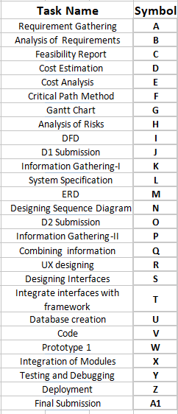

**Sequence Activities and Estimate Activity Completion**

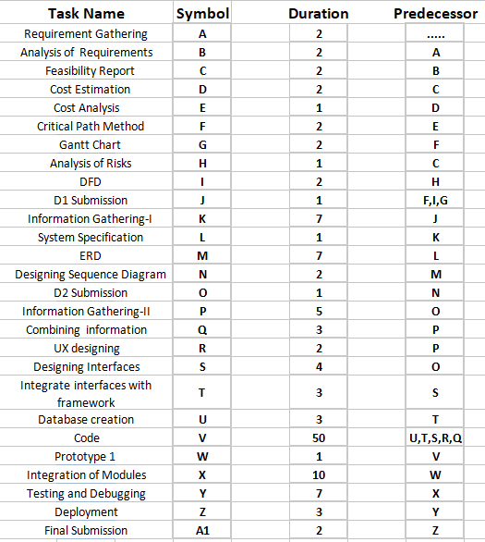

***Critical Path Evaluation***

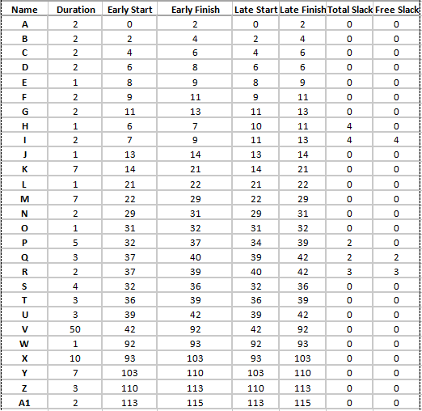

**Network Diagram**

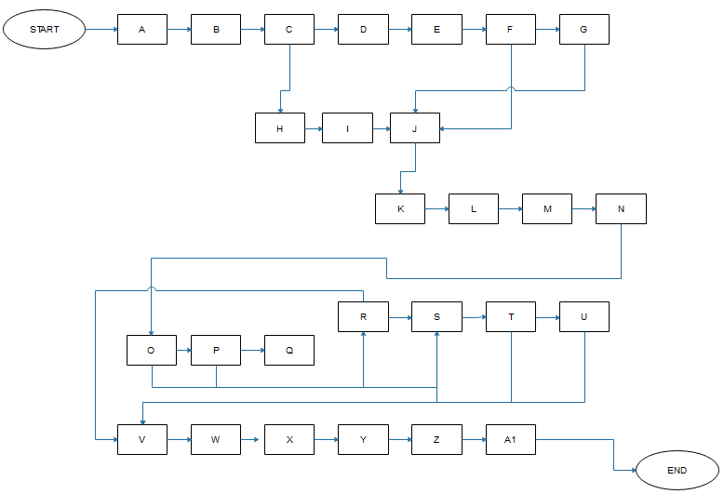

**Critical Path**

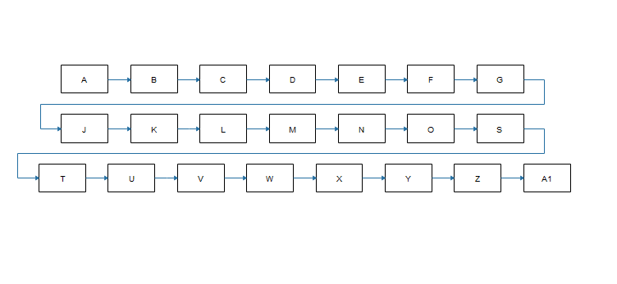

## 1.5 Gantt chart

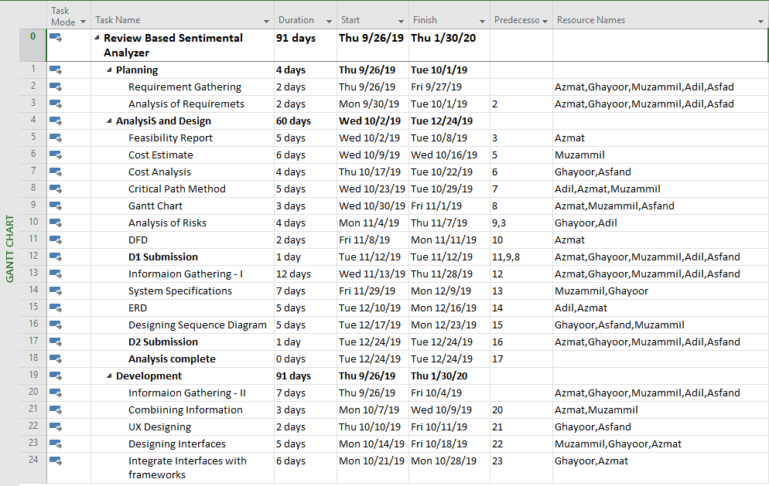

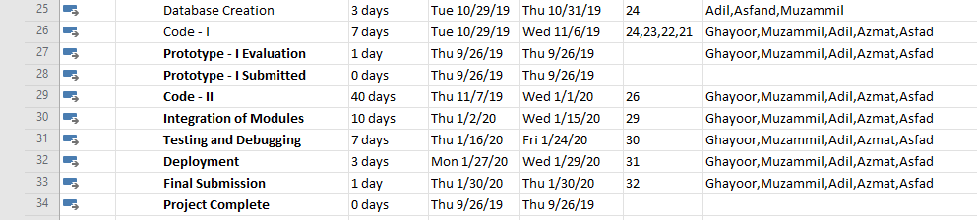

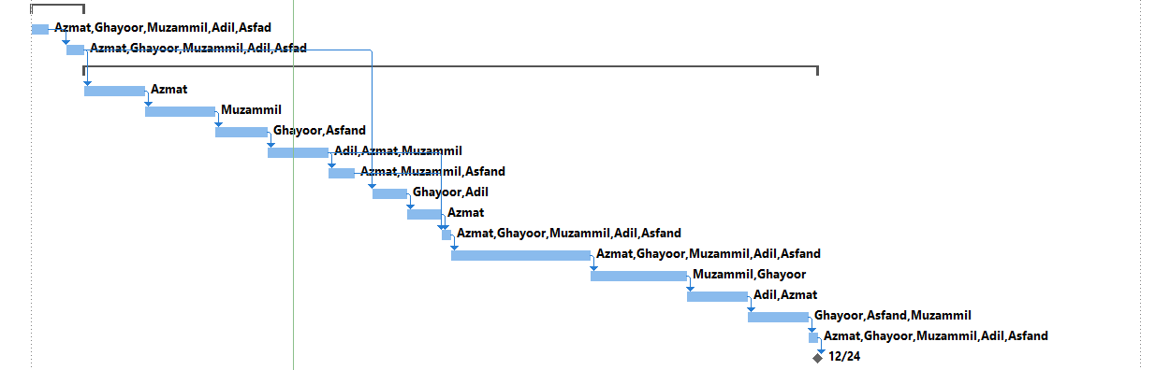

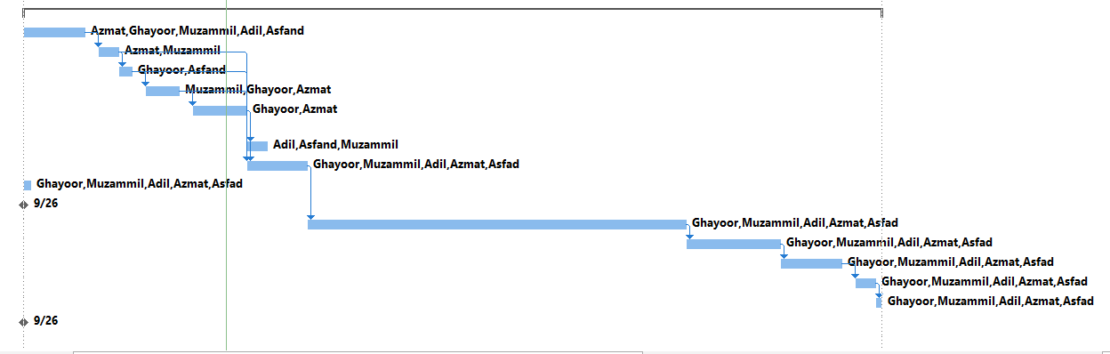

## 1.6 Introduction to Team members and their skill set

|  |  |  |  |
| --- | --- | --- | --- |
|  | **Member Information** | | **Skills Set** |
| 1 | **Ghayoor ul Haq** | **BITF16A523** | **Specialization:** Information Technology  **Project relevant skills**: He is good in hybrid mobile application developed as he worked on real time project as part time in market. |
| 2 | **Muzamil Murtaza** | **BITF16A525** | **Specialization:** Web Development and Management.  **Project relevant skills:** He has developed good skills in web development especially in JS Frameworks like React.js. Besides programming, he is also good at managing things |
| 3 | **Azmat Ali** | **BITF16A517** | **Specialization:** Information Technology  **Project relevant skills:** Besides web development, he is good in designing database. He has worked on extensible database structures. He has worked with Django framework of python, in market. |
| 4 | **Adil Ashraf** | **BITF16A513** | **Specialization:** Information Technology  **Project relevant skills:** He is developing front end designs in HTML, CSS and JAVASCRIPTS effectively. He has a good hand in Django Python. |
| 5 | **Afsand Yar** | **BITF16A535** | **Specialization:** Information Technology  **Project relevant skills:** He is good in web development and building logics. He can work on backend effectively (Python, PHP, Dot NET). |

## 1.7 Tools and Technology with reasoning

This project will use HTML, CSS, Bootstrap, Javascript, Python, Django, SQL, React Js and Flutter.

|  |  |  |  |
| --- | --- | --- | --- |
|  | **Tools and Techniques** |  | **Reasons** |
| 1 | **HTML** | It will be used to create web page structure. | |
| 2 | **CSS** | It is used to style the views of the site. | |
|  | **Python 3.x** | It's often used as a “scripting language” for web applications (platform independent). This means that it can automate specific tasks. | |
| 3 | **Django 2.x** | Use to create the backend of web based application, a framework of python provides number of built in function to work efficiently | |
| 4 | **PyCharm** | It is an Integrated Development Environment used for the Python language. We are using it for python scripting for server side. | |
| 5 | **SQL** | SQL is used to communicate with a database. | |
| 6 | **React Js** | Its a framework of javascript that used API’s and provides the ultimate performance for a webpage. This is developed by FACEBOOK | |
| 7 | **Flutter** | Flutter is framework of dart and developed by google. It provides us the way to develop iOS and Android Application using one code base. | |

## 1.8 Vision Document

**Problem Statement**:

Large number of reviews/feedbacks are collected in restaurants on a daily basis but owners are not getting benefit from it. They only get those reviews that are positive.

**Solution**:

This is an application that will allow the owners of restaurants to view all the review either positive or negative digitally. He can then executes campaigns to make the unhappy customers happy.

**Actors**:

There are three main actors in this project.

* Customer
* Owner
* Adminstrator

## 1.9 Risk List

Following are some risks that have been identified in our project. The risks are given in decreasing order according to the severity. And this list will be updated later in the project as we face any other possible risks. The list in decreasing order of importance along with mitigation or contingency actions is as follows:

1. **Time Management:**

Scope and functionality of the project must comply to the schedules otherwise project completion may be delayed.

**Mitigation or contingency actions:** All the team members of the project must strictly follow the schedules.

1. **Technology Advancement:**

Technology is changing day by day. Advancement in technology may not accept the terms used in our project.

**Mitigation or contingency actions:** Develop the project considering maintainability aspects.

1. **Business Aspects:**

If target audience is not aware of such a website, website will be of no use.

**Mitigation or contingency actions:** Marketing of the project done properly building interest of restaurants.

1. **Team Members:**

Issues Whole work is divided in the team members according to their skills. In case of any member’s absence in the meeting, there may be a difficulty in completing the project in time.

**Mitigation or contingency actions:** Team members are very strictly made to attend every meeting.

1. **Wrong Reviews**

Customer can give wrong reviews and owner can get wrong information from this platform because reviews are building block of this project.

**Mitigation or contingency actions:** Customers will be encouraged to provide honest reviews.

*********************REQUIREMENTS ENGINEERING*********************

## 1 Introduction

Requirements engineering process provides the appropriate mechanism for understanding what the customer wants, analyzing need, assessing feasibility, negotiating a reasonable solution, specifying the solution unambiguously, validating the specification and managing the requirements as they are transformed into an operational system. The task of capturing, structuring, and accurately representing the user's requirements so that they can be correctly embodied in systems which meet those requirements (i.e. are of good quality).

* Requirements elicitation
* Requirements analysis and negotiation
* Requirements specification
* System modeling
* Requirements validation
* Requirements management

Here, requirements specification is to be discussed. Requirements specification would lead to the following four steps:

* Identify external interfaces
* Development of context diagram
* Capture “shall statements
* Allocate requirements
* Prioritize requirements
* Development of requirements traceability matrix

### 1.1 Systems Specifications

The following are the clauses that must be included while describing the system specifications.

**Introduction**

Large number of reviews/feedbacks are collected in restaurants on a daily basis but owners are not getting benefit from it. They only get those reviews that are positive. This will provide owner ther birds eye view of the restaurant that what is actually going on.

**Existing System**

There is no other system in Pakistan that is fully functional and provide best services

**Organizational Chart**

We are not developing this website for any specific organization so there is no organizational chart.

**Scope of the System**

This application can be used by only owner, customer and administrator.

Owner can:

* Login
* Logout
* Check review (Filtering)
* Execute Campaigns

Customer can:

* Provide the review using mobile application

Administrator can:

* Login
* Check reviews
* Manage Owner’s details and accounts
* Logout

**Summary of Requirements (Initial Requirements)**

The system must fulfill the following requirements:

* **Save Reviews:**

System must save the customers reviews against the specific restaurant and food as well.

* **Check Review:**

There must be some way to show the reviews to owners

* **Provide Better Solutions to Owners**

Our system should provide guidance to the restaurant owners.

### 1.2 Identifying External Entities

The Identification of External Entities is done in two phases.

**a. Over Specify Entities from Abstract**

* Customer
* Owner
* Admin

**b. Perform Refinement**

* Internet
* Database
* Reviews
* Reports of Reviews

### 1.3 Context Level Data Flow Diagram

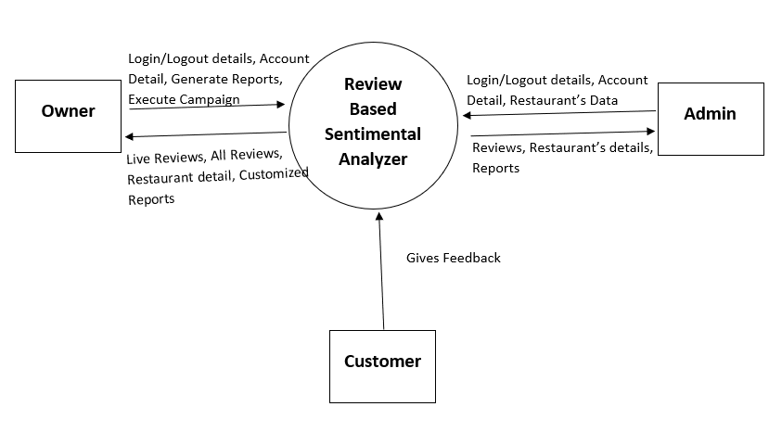

### 1.4 Capture "shall" Statements

|  |  |
| --- | --- |
| **External Entities** | **Initial Requirements** |
| Admin | Shall login on website |
| Admin | Shall check the reviews |
| Admin | Shall logout from website |
| Admin | Shall select logout option |
| Owner | Shall login to website |
| Owner | Shall check all the reviews |
| Owner | Shall Execute Campaigns |
| Owner | Shall logout |
| Customer | Shall Give probe review |

### 1.6 Allocate Requirements

|  |  |  |
| --- | --- | --- |
| **External Entities** | **Initial Requirements** | **Use Case Name** |
| Admin | Shall login on website | UC_login |
| Admin | Shall check the reviews | UC_review_check |
| Admin | Shall logout from website | UC_logout |
| Admin | Shall sign in | UC_sign_in |
| Owner | Shall login to website | UC_log_in |
| Owner | Shall check all the reviews | UC_check_review |
| Owner | Shall Execute Campaigns | UC_campaigns |
| Owner | Shall logout | UC_log_out |
| Customer | Shall Give probe review | UC_give_review |

### 

### 1.7 Prioritize Requirements

|  |  |  |  |
| --- | --- | --- | --- |
| **Priority** | **External Entities** | **Initial Requirements** | **Use Case Name** |
| High | Admin | Shall login on website | UC_login |
| Medium | Admin | Shall check the reviews | UC_review_check |
| Low | Admin | Shall logout from website | UC_logout |
| High | Admin | Shall sign in | UC_sign_in |
| Medium | Owner | Shall login to website | UC_log_in |
| High | Owner | Shall check all the reviews | UC_check_review |
| Medium | Owner | Shall Execute Campaigns | UC_campaigns |
| Low | Owner | Shall logout | UC_log_out |
| High | Customer | Shall Give probe review | UC_give_review |

### 1.8 Requirements Trace-ability Matrix

|  |  |  |  |
| --- | --- | --- | --- |
| **Initial Requirements** | **Build** | **Use Case Name** | **Category** |
| Shall login on website | B1 | UC_login | Functional |
| Shall check the reviews | B1 | UC_review_check | Functional |
| Shall logout from website | B1 | UC_logout | Functional |
| Shall sign in | B1 | UC_sign_in | Functional |
| Shall login to website | B1 | UC_log_in | Functional |
| Shall check all the reviews | B1 | UC_check_review | Functional |
| Shall Execute Campaigns | B1 | UC_campaigns | Functional |
| Shall logout | B1 | UC_log_out | Functional |
| Shall Give probe review | B1 | UC_give_review | Functional |

### 1.9 High Level Use-Case Diagram

